|  |
| --- |
| **Lockedme.com**  **(Application Screenshot**s) |

Version History

|  |  |
| --- | --- |
| Author | Solanki Mayur BharatBhai |
| Purpose | Screenshot of the Application |
| Date | 14th Aug 2021 |
| Version | 1.0 |

Table of Contents

* This is Main Menu screen-shot 3

1.Display All file Screenshot 4

2. Add new file Screenshot 5

3. Delete a file Screenshot 6

4. Search a file Screenshot 7

7

5. Exit Screenshot 8

8

# 1. This is Main Menu screen-shot

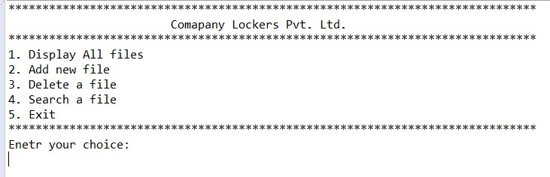

# 1. Display All file Screenshot

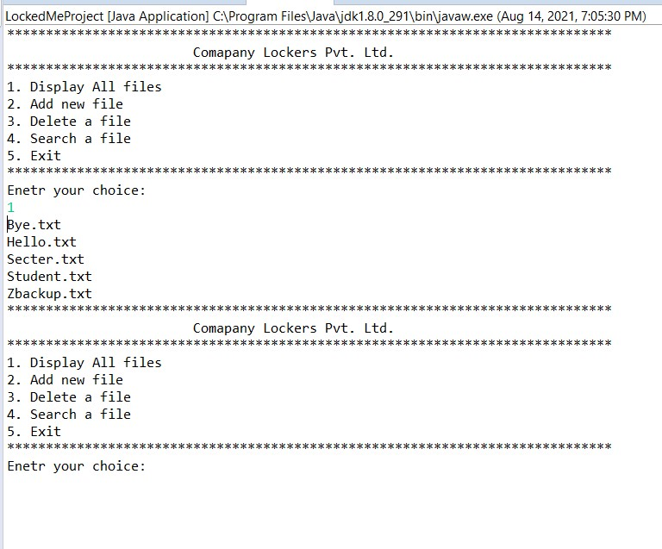

# 2. Add new file Screenshot

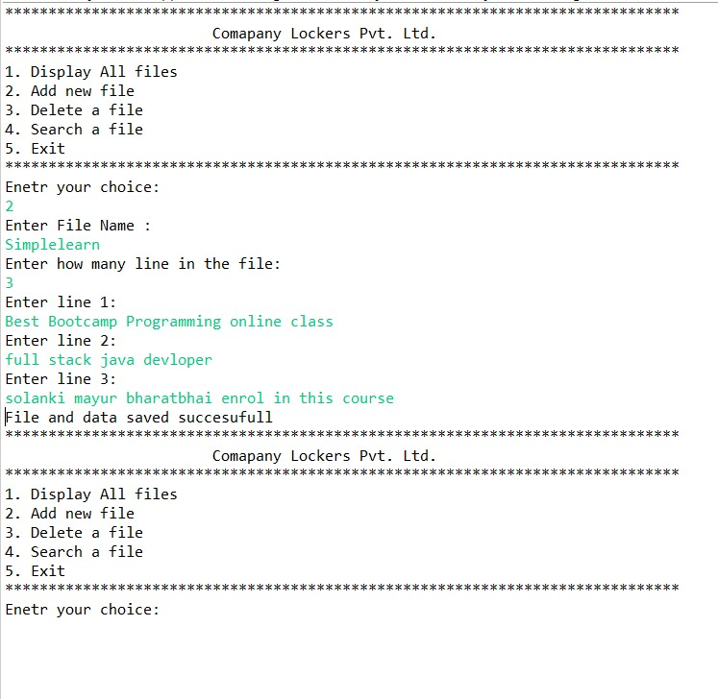

# 3. Delete a file Screenshot

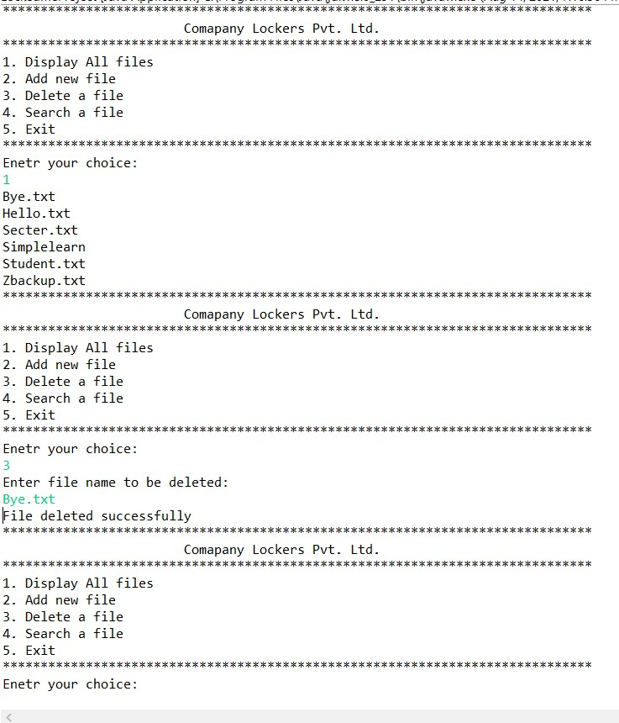

# 4. Search a file Screenshot

# C:\Users\Maur\Downloads\Screenshot5.jpg

# 5. Exit Screenshot

# C:\Users\Maur\Downloads\Screenshot6.jpg